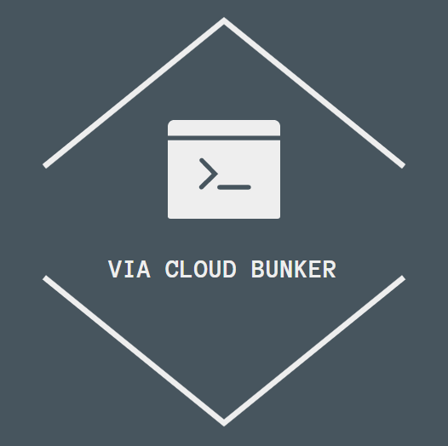

**Installation guide**

**Introduction**

Via CloudBunker is a file-sharing program designed for the needs of the Engineering department of VIA University College.

**Getting started**

When you receive the program it will be in a zip file. Extract the files in order to countinue with the Installation guide.

Step 1: Server and Database

Designate a system that will serve as a server for the application. Then you need to create the database. The program is using [PostgreSQL](https://www.postgresql.org/download/) as a database. Download it and follow the installation guide for PostgreSQL. You need to remember your password as it will be important further down.

Step 2: Libraries

When you have received the program you will need to configure the dependencies for the SEP module. In the zipped file you will find postgresql-42.2.8.jar and a folder called javafx-sdk-11.0.2. They need to be added to the dependencies.

Step 3: Creating the database

In the SEP module in the source folder under network and database there are 3 classes that need personal touch. In those 3 classes there is a field for a password. That password will be the password you created when installing the database.

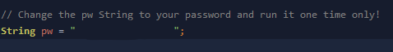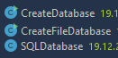

CreateDatabase and CreateFileDatabase should only be run once.

Step 4: Starting the server

In the folder network under server there is a class called server. It should be ran on the server machine in order for the clients to connect. *Remember when the server in not running no client can connect*

Step 5: Installing on client computers

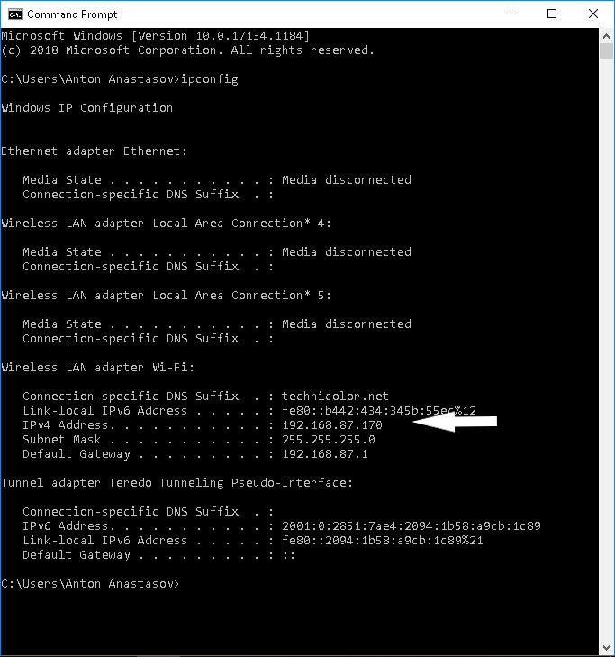After the server is operational on the server machine, in the search filed on the taskbar search for cmd. After the Command Prompt opens type the command *ipconfig.*

You are looking for the IPv4 address of the server machine. Save it somewhere as it will be used later.

4.pngWhen installing on the client machine/s a modification needs to be made to the SocketClient class. It could be found under network and then client.

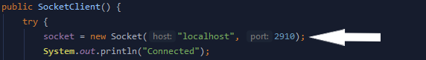

In the place of *localhost,* copy the IP for the server machine.

Step 6: Starting the program for the first time

The program could be started by running the *StartApplication* class.

If the login screen appears that means that you have successfully completed the installation guide for CloudBunker. If you have any further questions about how to operate the program consul the User Guide that is available to you.

If you experience any problems don’t hesitate to contact us on our e-mail :

[anton.anastasov@outlook.com](mailto:anton.anastasov@outlook.com)

**Thank you for choosing our product!**